# WEEK 2: PL/SQL Programming

**EXERCISE 1**:

## Scenario 1: Discount for Customers Above 60

The bank wants to apply a discount (1%) to loan interest rates for customers above 60 years old.

**QUERY:**

BEGIN

DBMS_OUTPUT.PUT_LINE('--- Scenario 1: Discount for Customers Above 60 ---');

FOR cust IN (

SELECT c.CustomerID, c.Name, c.DOB, l.LoanID, l.InterestRate

FROM Customers c

JOIN Loans l ON c.CustomerID = l.CustomerID

) LOOP

IF MONTHS_BETWEEN(SYSDATE, cust.DOB) / 12 > 60 THEN

UPDATE Loans

SET InterestRate = InterestRate - 1

WHERE LoanID = cust.LoanID;

DBMS_OUTPUT.PUT_LINE('1% discount applied to Customer ' || cust.Name ||

' | Old InterestRate: ' || cust.InterestRate ||

' | New: ' || (cust.InterestRate - 1));

END IF;

END LOOP;

COMMIT;

END;

/

**OUTPUT:**

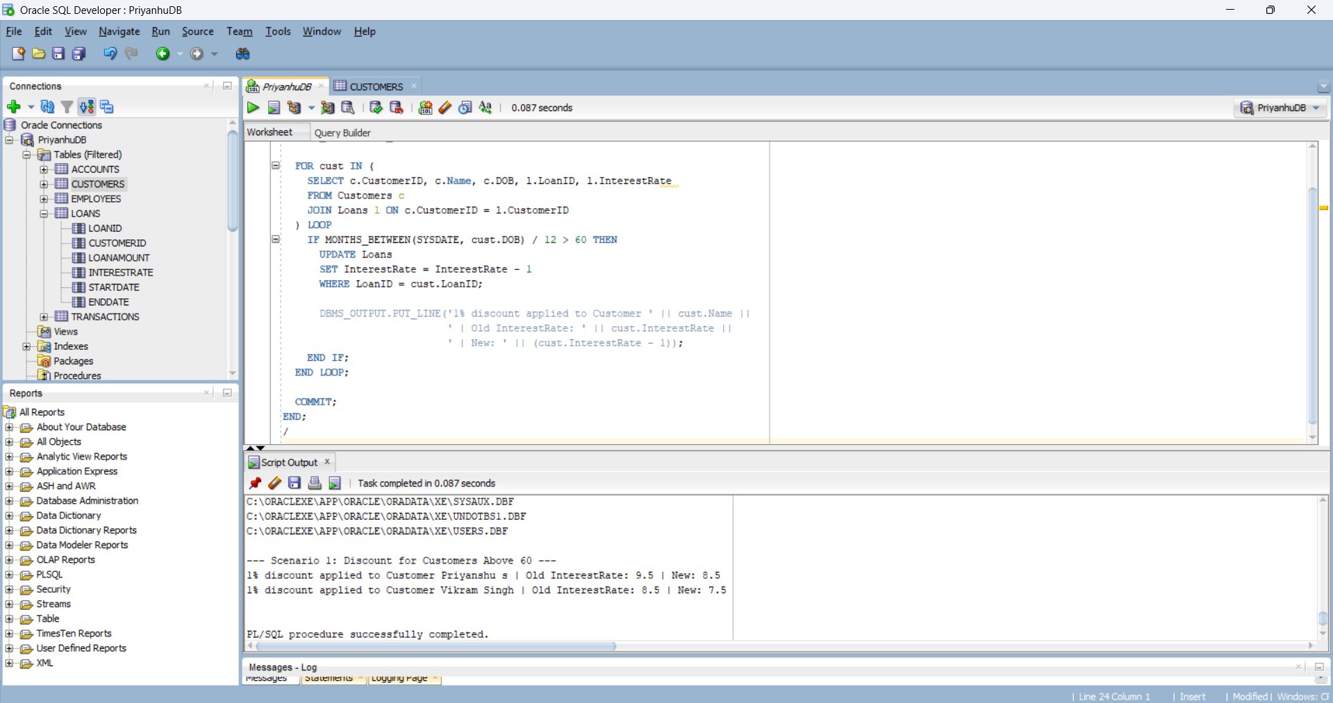

## Scenario 2: VIP Status Update

A customer can be promoted to VIP status based on their balance (Balance > $10,000).

**QUERY:**

BEGIN  
 DBMS_OUTPUT.PUT_LINE(CHR(10) || '--- Scenario 2: VIP Status Update ---');  
   
 FOR cust IN (SELECT CustomerID, Name, Balance FROM Customers) LOOP  
 IF cust.Balance > 10000 THEN  
 UPDATE Customers  
 SET IsVIP = 'TRUE'  
 WHERE CustomerID = cust.CustomerID;  
   
 DBMS_OUTPUT.PUT_LINE( cust.Name || ' promoted to VIP status.');  
 ELSE  
 UPDATE Customers  
 SET IsVIP = 'FALSE'  
 WHERE CustomerID = cust.CustomerID;  
   
 DBMS_OUTPUT.PUT_LINE( cust.Name || ' is not eligible for VIP status.');  
 END IF;  
 END LOOP;  
   
 COMMIT;  
END;  
/

**OUTPUT:**

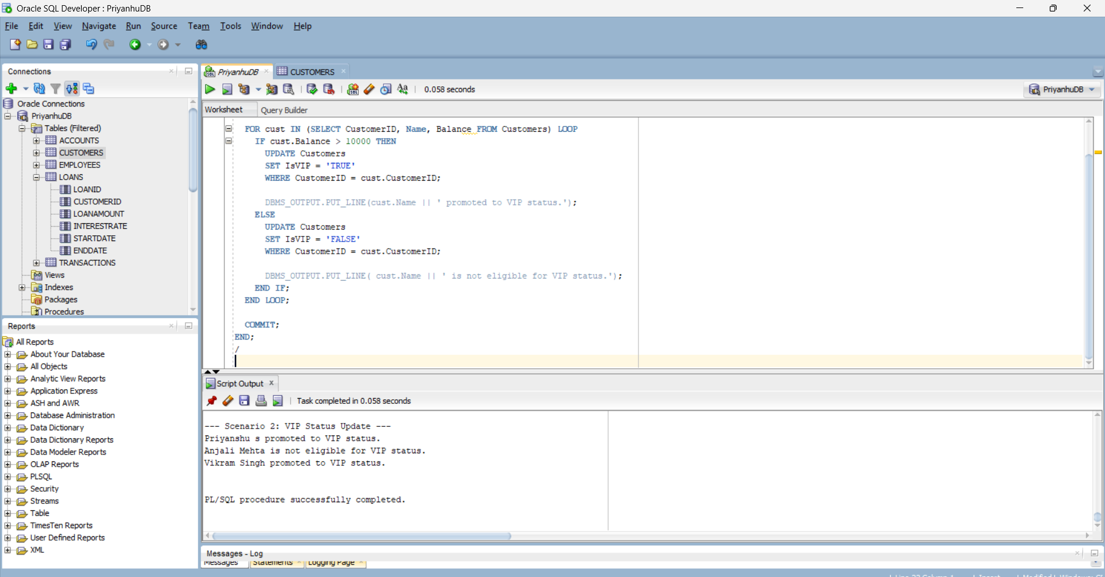

## Scenario 3: Loan Due Reminders

The bank wants to send reminders to customers whose loans are due within the next 30 days.

**QUERY:**

BEGIN  
 DBMS_OUTPUT.PUT_LINE(CHR(10) || '--- Scenario 3: Loan Due Reminders ---');  
   
 FOR loan IN (  
 SELECT l.LoanID, l.CustomerID, l.EndDate, c.Name  
 FROM Loans l  
 JOIN Customers c ON c.CustomerID = l.CustomerID  
 WHERE l.EndDate BETWEEN SYSDATE AND SYSDATE + 30  
 ) LOOP  
 DBMS_OUTPUT.PUT_LINE(' Reminder: Loan ID ' || loan.LoanID ||   
 ' for customer ' || loan.Name ||   
 ' is due on ' || TO_CHAR(loan.EndDate, 'DD-MON-YYYY'));  
 END LOOP;  
END;  
/

**OUTPUT:**

